

WEDE6021

PART 2



May 9, 2024

aALIYAH ALLIE ST10212542

NICOL BLACK ST10391534

Contents

DATABASE TABLES 2

CLOTHING STORE DATABASE: 2

TABLE ADMIN 2

TABLE CLOTHES 2

TABLE CUSTOMERS 3

TABLE ORDERS 3

TABLE USERS 3

# DATABASE TABLES

## CLOTHING STORE DATABASE:

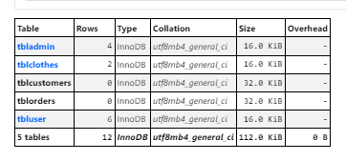

### TABLE ADMIN

### TABLE CLOTHES

### TABLE CUSTOMERS

<TO BE DONE IN PART 3>

### TABLE ORDERS

<TO BE DONE IN PART 3>

### TABLE USERS

# DATABASE ADMIN CONTROLS

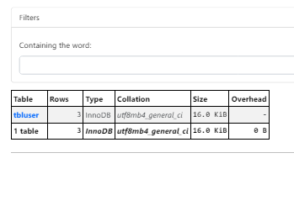

## tblUser

